**Project Report**

**Aawaj**

**-By Kammula Keerthi**

**22EEB0B21**

* **Video to audio converter**
* **Audio to text converter**

**Summary:**

**Aawaj is a versatile multimedia application enabling users to seamlessly convert videos to audio files and transcribe audio content to text. The application offers a streamlined experience, incorporating features such as audio playback and document saving. Aawaj stands as a comprehensive tool for multimedia conversion, fostering accessibility and convenience for users seeking efficient video-to-audio and audio-to-text transformations.**

**Introduction**

**Significance:**

**The significance of this project lies in addressing the growing need for efficient and user-friendly tools that facilitate multimedia manipulation.**

* **On one hand, it allows users to extract audio content from video files, catering to situations where users may want to listen to the audio separately or convert it into a different format.**
* **On the other hand, the project also empowers users to convert audio files into text, offering a valuable tool for transcription, accessibility, and content analysis.**

**Objective:**

**This dual-purpose functionality serves various user needs and scenarios, addressing the following objectives:**

**1. Efficient Multimedia Handling**

**2. Content Consumption Flexibility**

**3. Provide Real-time User Feedback**

**4. User-Friendly Interface**

**5. Local Storage Convenience**

**Technologies, libraries, and modules used in the project :**

1. **Tkinter:**

**Tkinter is used for developing the graphical user interface (GUI) of the application, providing a set of tools for creating windows, buttons, and other GUI elements.**

1. **speech_recognition:**

**This library is employed for audio processing, specifically for recognizing speech in audio files. It allows the application to convert spoken words into text.**

1. **pydub:**

**Pydub is used for audio processing and manipulation. In this project, it plays a key role in converting video files to audio files.**

1. **moviepy.editor:**

**Moviepy is utilized for video processing, enabling the extraction of audio from video files. It contributes to the video-to-audio conversion functionality.**

1. **tempfile:**

**Tempfile is used for creating temporary files, which is especially used in the project for managing temporary audio and document files.**

**Implementation**

**Open the GUI application**

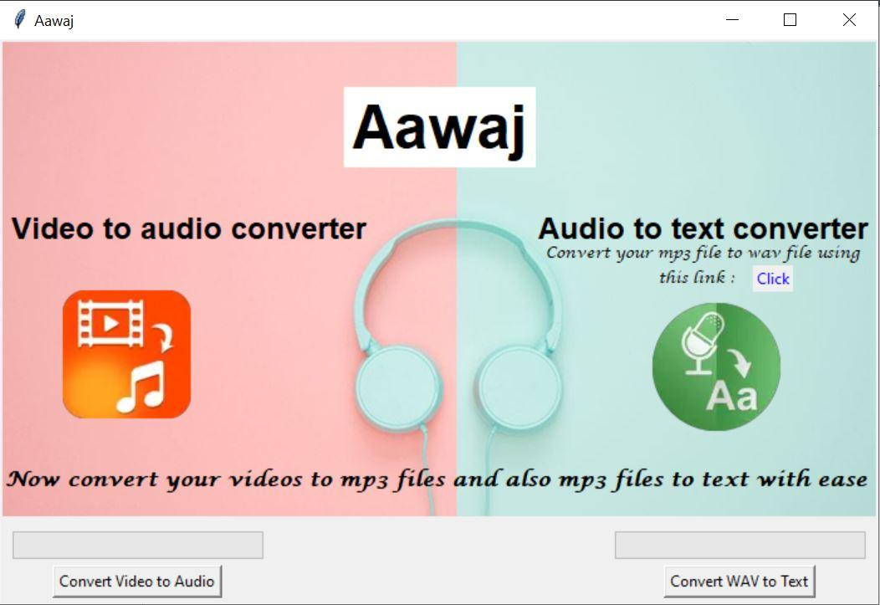

**Steps to convert video to audio**

**Step 1: To convert video to audio, click the button Convert Video to Audio and the user can upload the video.**

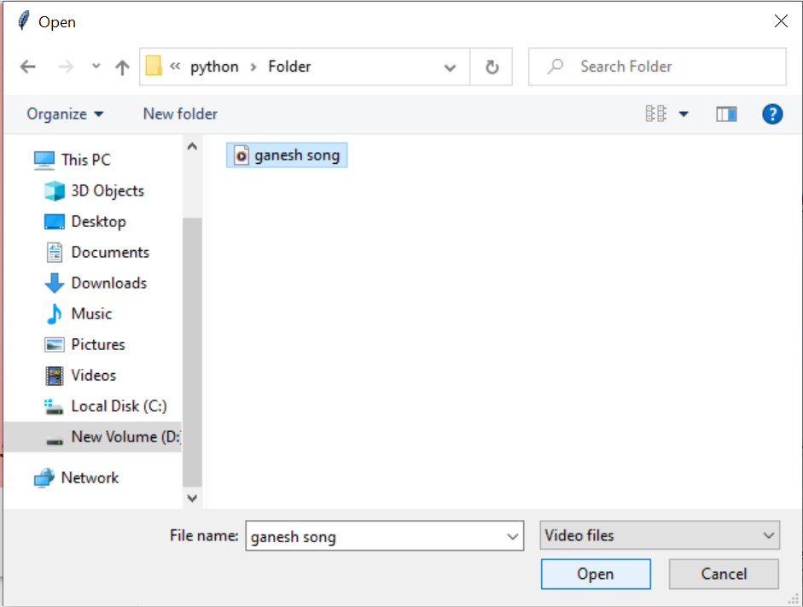

**Step 2: While the video is getting converted to audio, we can see the progress of loading bar.**

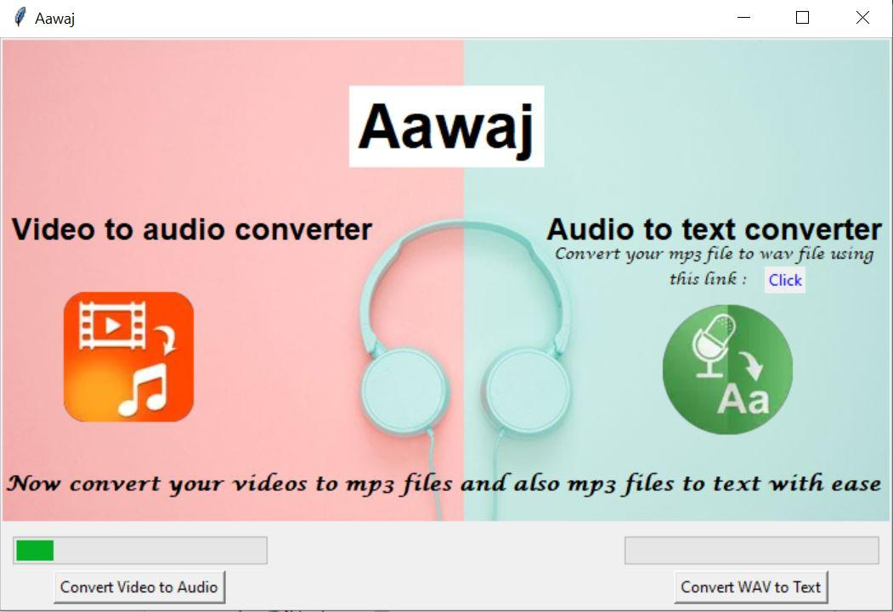

**Step 3: We get an option to listen to the audio file**

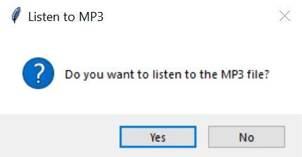

**Step 4: If the user clicks yes, he can listen to the mp3 file using windows media player. A temporary mp3 file is created here.**

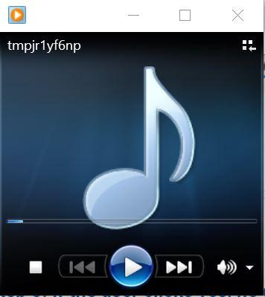

**Step 5: The user then gets an option to save the mp3 file.**

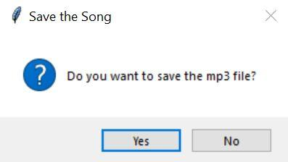

**Step 6: On clicking Yes, the mp3 file is saved. The user has the flexibility to save it in the location of their choice.**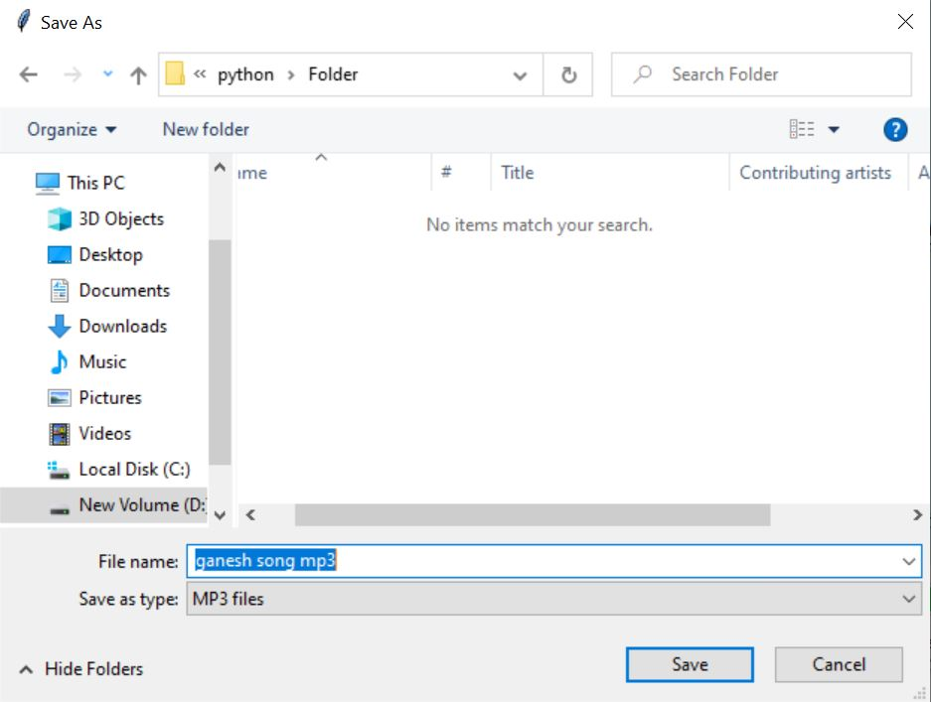

**Step 7: After mp3 the file is saved, the user gets a page displaying that the file is saved.** 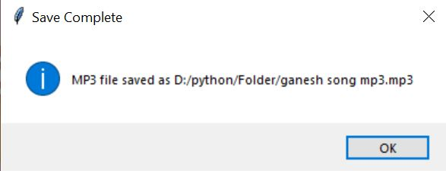

**Steps to convert audio to text**

**Step 1: To convert an mp3 file to text, click the convert mp3 to text button and select the appropriate mp3 file.**

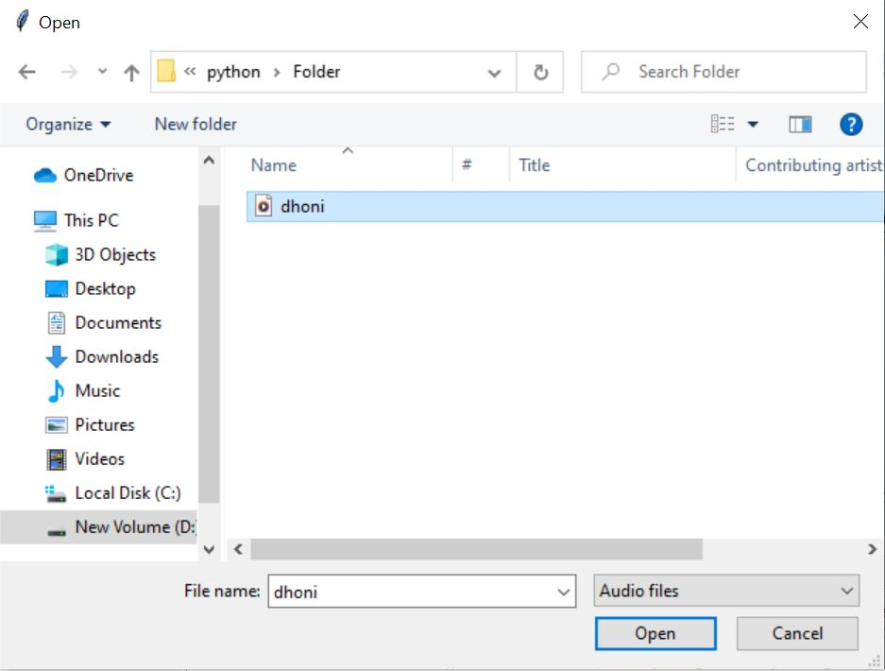

**Step 2: While the mp3 file is getting converted to text, the loading bar progresses.**

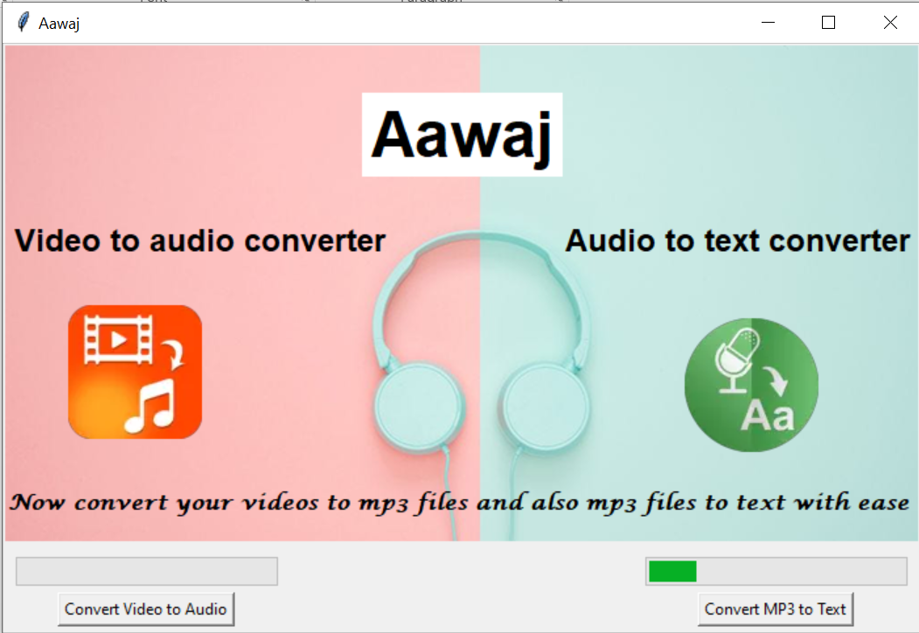

**Step 3: After converting mp3 to text and storing it in temporary word document, we get an option to open the docx file. The docx file is stored as a temporary file.**

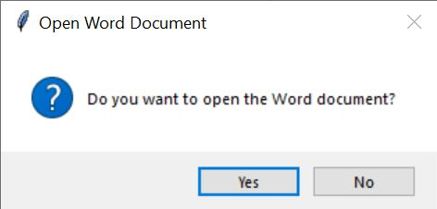

**Step 4: On clicking Yes, the word document with the text is opened.**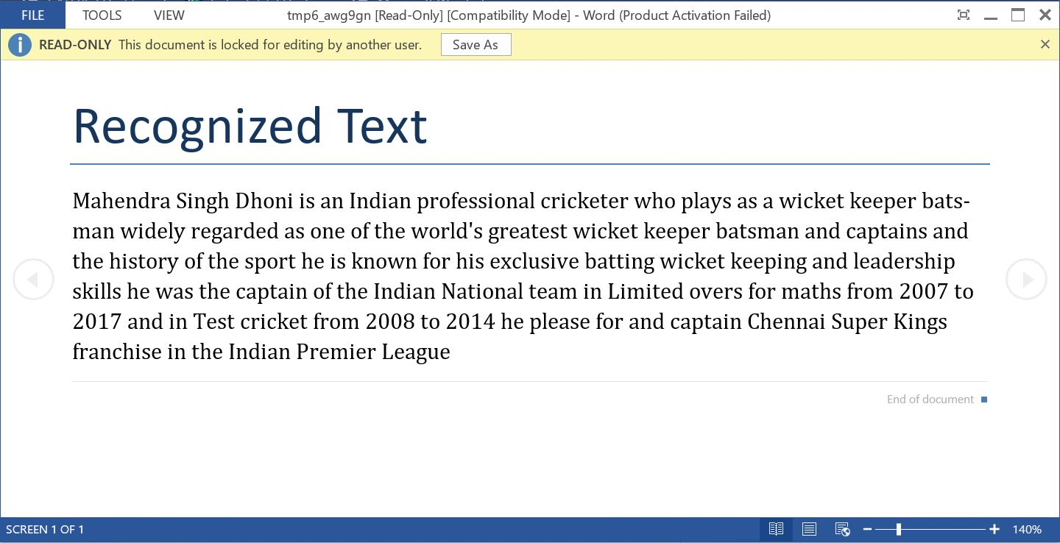

**Step 5: Then the user gets an option to save the word document.**

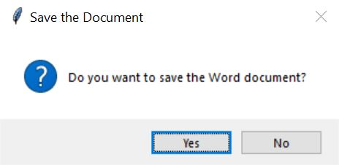

**Step 6: On clicking Yes, the user can save the word document file in the desired location.** 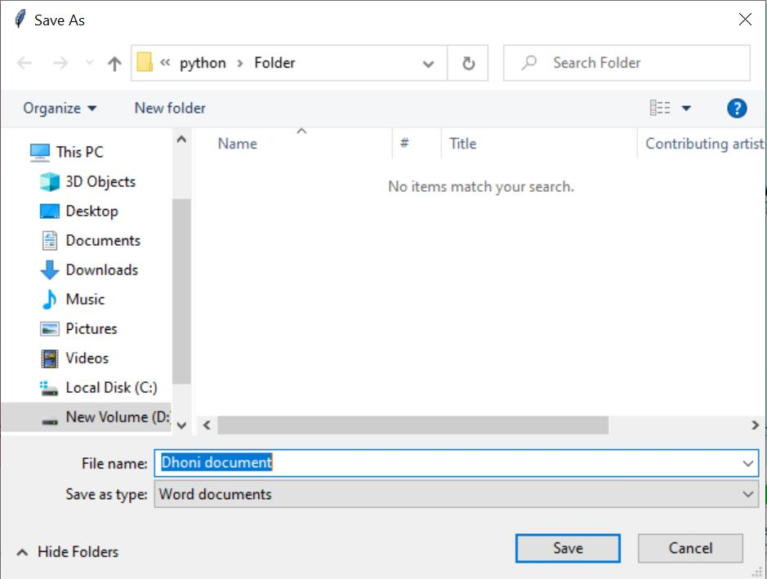

**Step 7: After the word document file is saved, the user gets a page displaying that the file is saved.**

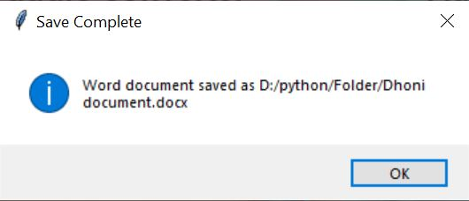

**Conclusion**

**In conclusion, the "Aawaj" project is a solution designed to adapt to the evolving needs of users in a digital landscape saturated with diverse multimedia content. The dual-purpose functionality addresses various scenarios, from personal audio extraction to professional transcription services, making it a valuable asset for content creators, educators, and individuals with accessibility needs.**

**GitHub repository link:**

https://github.com/Keerthi29062005/Aawaj--Python-project.git